Bulverde/Spring Branch Angels  Angel Tree Project – Child Gift Sheet  PLEASE FILL OUT A SEPARATE SHEET FOR EACH CHILD. | 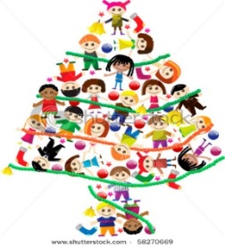
Child’s Information
Child’s Name
Date of Birth
Age
Male or Female?
Clothing
Item | Size
Coat
Shirt/Blouse
Pants/Jeans
Shoes
Socks
Underwear
Pajamas
Other
______________

Please list your child’s size and whether they are Toddler, Youth, Adult, etc. for the following items.

Does your child have a winter coat?

____ Yes ____ No

Does your child need a blanket?

____ Yes ____ No

Of the clothing items listed above, please select top two most wanted items & tell us about them (brand, character theme, etc.). Please limit cost to $30 each.

1.

2.

Wish List

Please list two items your child is wishing for this Christmas. Please be specific & limit the cost of each gift to $30.
1.

2.

What is your child’s favorite color?

List some of your child’s favorites (sports, animals, hobbies, music, etc.):

